Pursuing the Spiritual Roots of Protest

A Historic Model for Discerning
Responses to Uncertain Times

Monday, September 29 - 7:00 p.m.
East Chestnut Street Mennonite Church
432 E Chestnut St, Lancaster, PA 17602

Co-sponsored by the Lancaster Mennonite Historical Society, Mennonite Central Committee U.S., the Lancaster Interchurch Peace Witness, Christian Peacemaker Teams (Lancaster Chapter) and 1040forPeace.org

Fifty years ago this November, several committed Christian peacemakers gathered for a retreat to discern meaningful nonviolent responses to a time of war and social crises. The retreat was hosted by Thomas Merton, at his Gethsemani Abbey in the hills of Kentucky. Among the participants in that historic gathering were Dan and Phil Berrigan, John Howard Yoder, A.J. Muste, Jim Forrest, and Tom Cornell. Together they processed ideas about contrasts between spiritual and social “privilege,” the role of technology, the relationship between church and society, our “right” to protest, sources of hope, and more.
The story of this event and its themes has been captured in a recently published book, Pursuing the Spiritual Roots of Protest: Merton, Berrigan, Yoder, and Muste at the Gethsemani Abbey Peacemakers Retreat. Gordon Oyer, the book’s author, will share from his story of that event and lead us in discussion on how that fifty-year-old conversation continues to inform and inspire us in our struggles for spiritually-grounded responses to the social challenges of our own times, including war and terrorism, economic inequities, and environmental dangers.

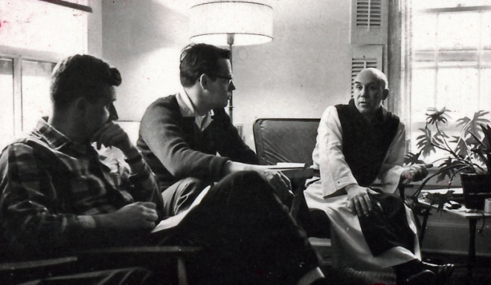
Thomas Merton (right) at the 1964 retreat of peacemakers.

For more information on the book and topic, visit http://gordonoyer.weebly.com/

For more information on this event and to RSVP, please contact
H.A. Penner at 717-859-3529 or penner@dejazzd.com

